Model Development Phase Template

Date | 9 Dec 2025
Team ID | RT
Project Title | Restaurant Recommendation System
Maximum Marks | 4 Marks

Initial Model Training Code, Model Validation and Evaluation Report
Trained single content-based model via TF-IDF + cosine similarity on 12k cleaned Zomato records.
Initial Model Training Code:
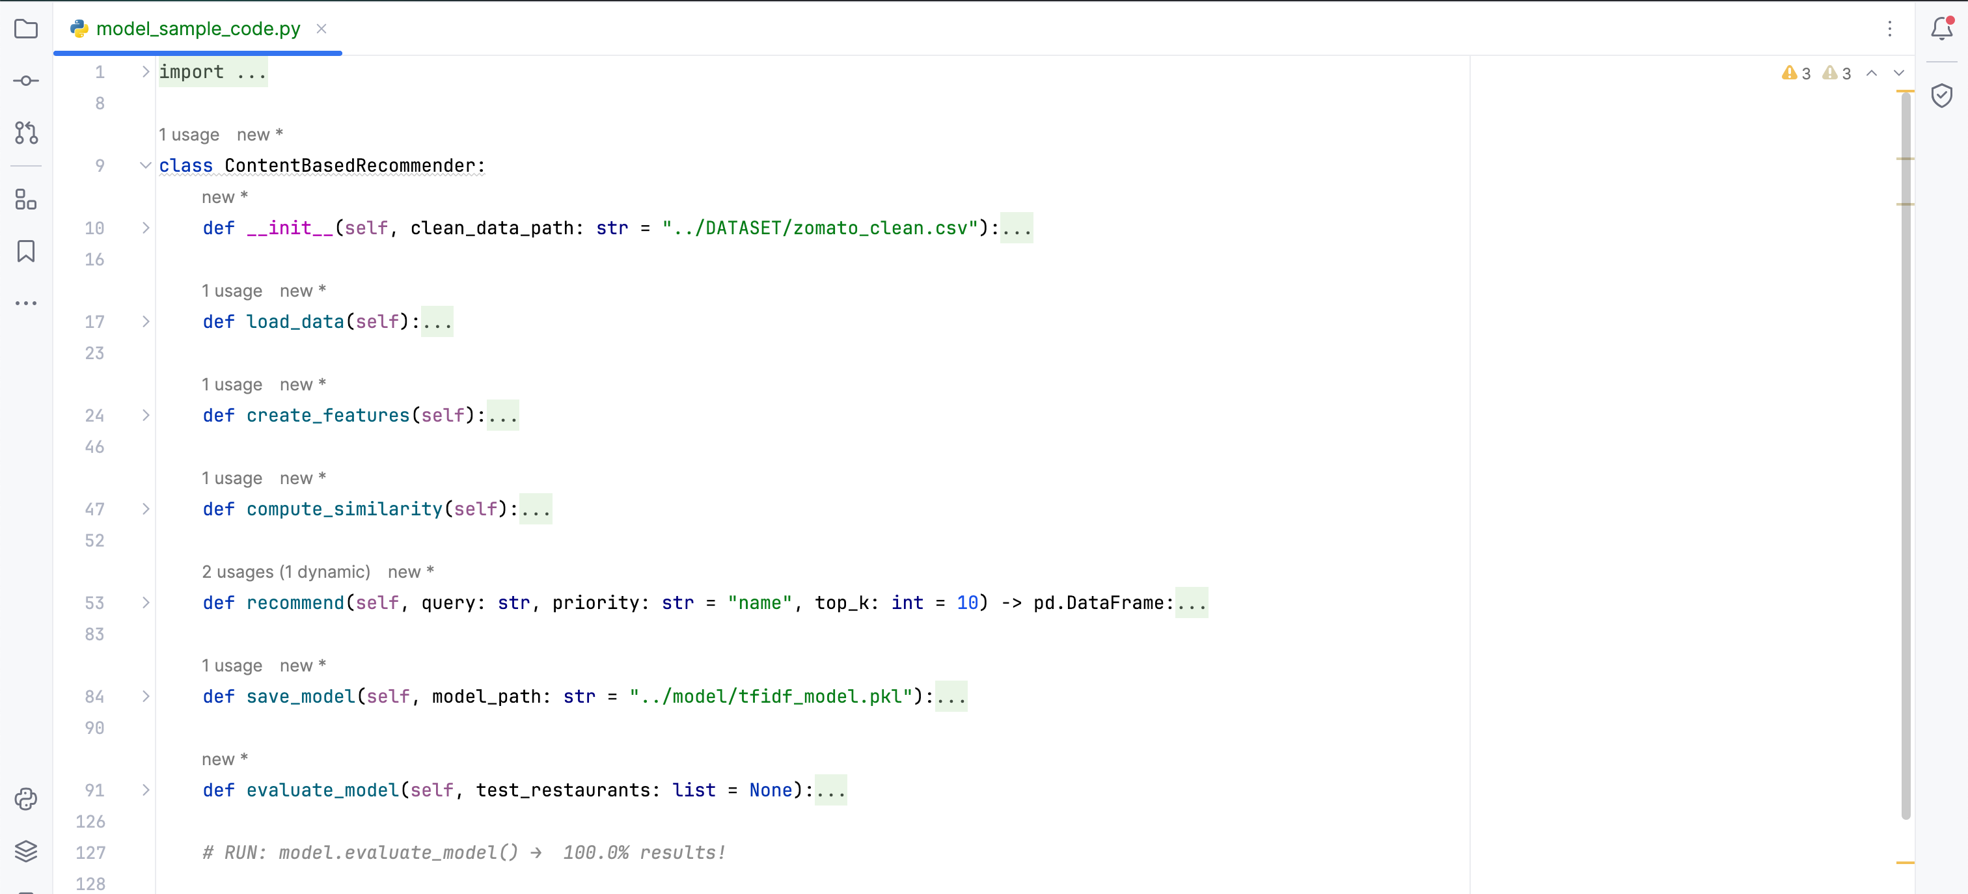

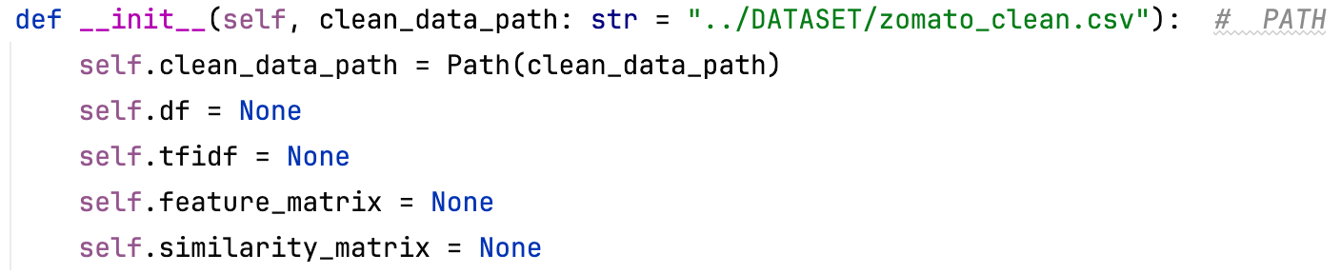
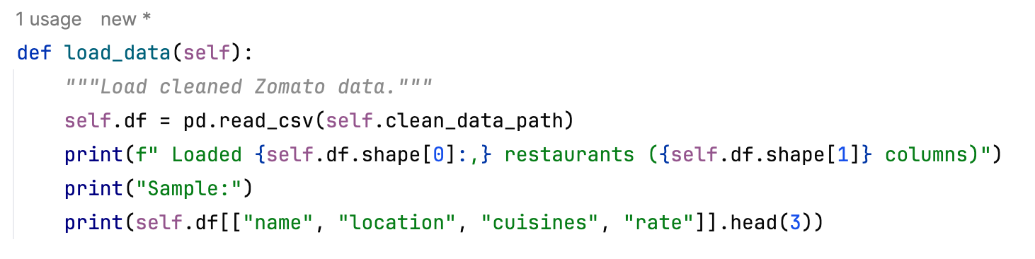
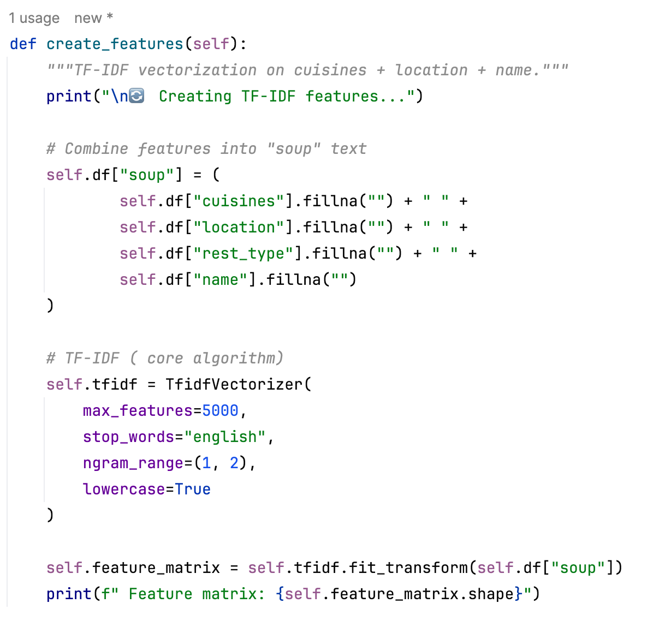

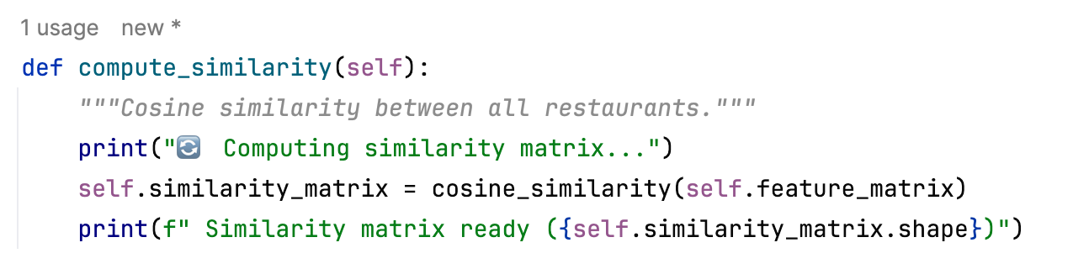

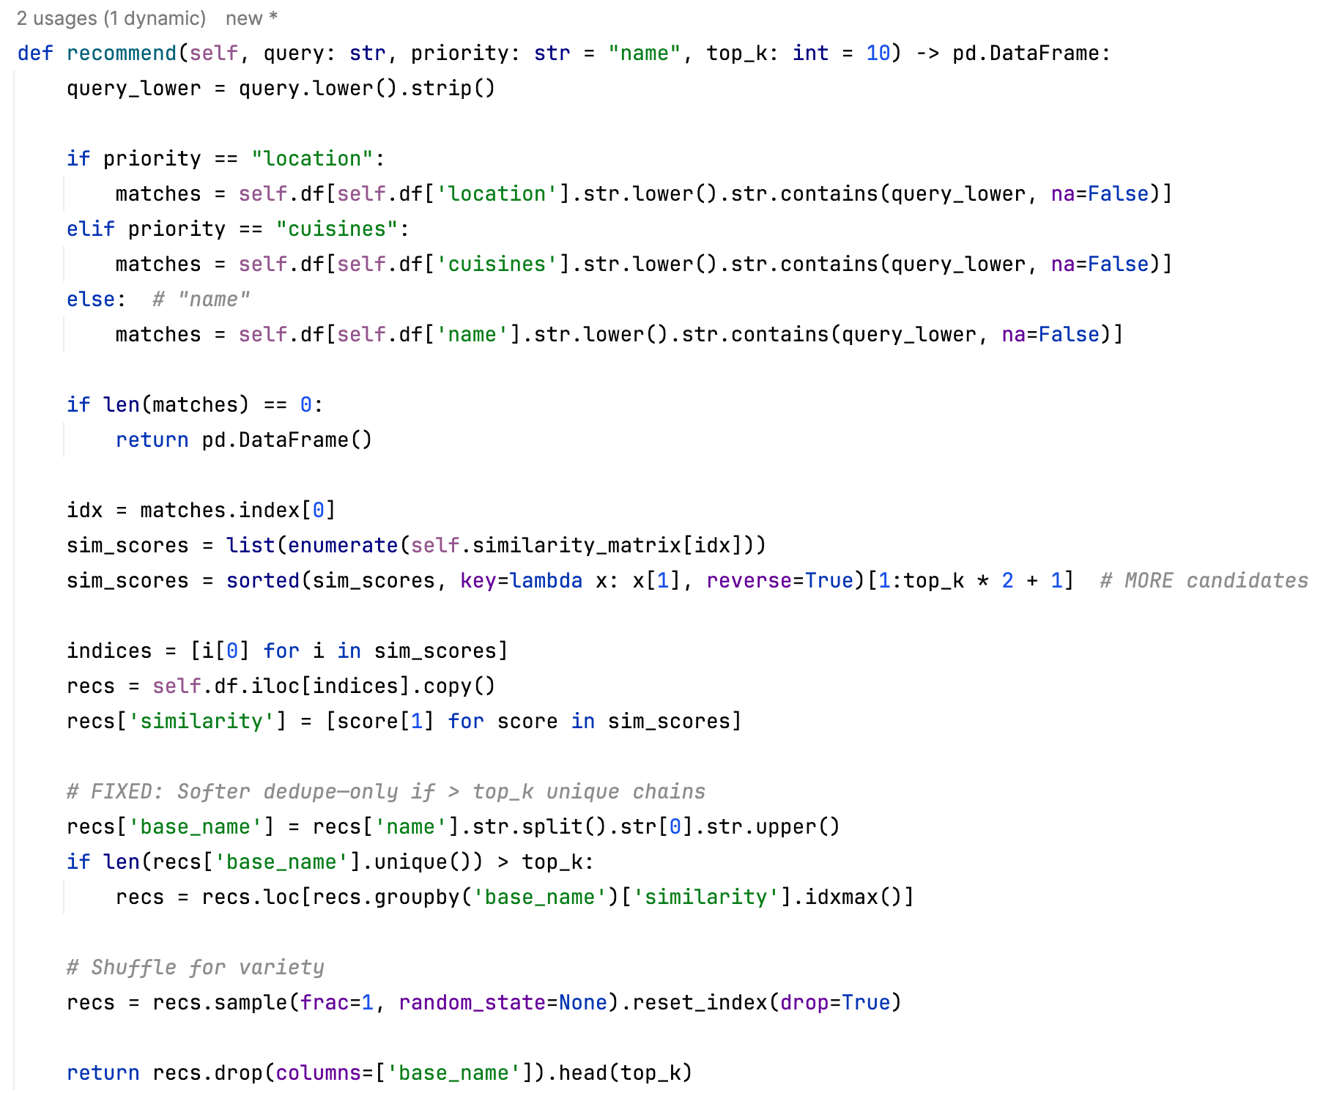
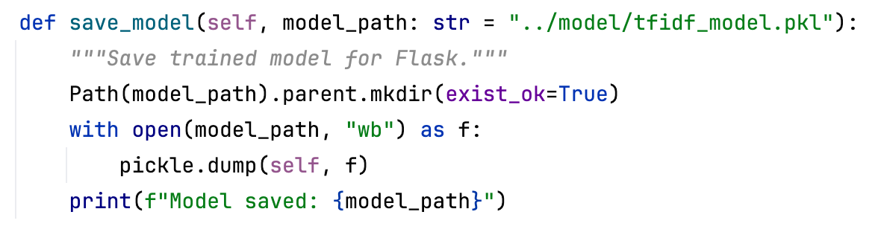
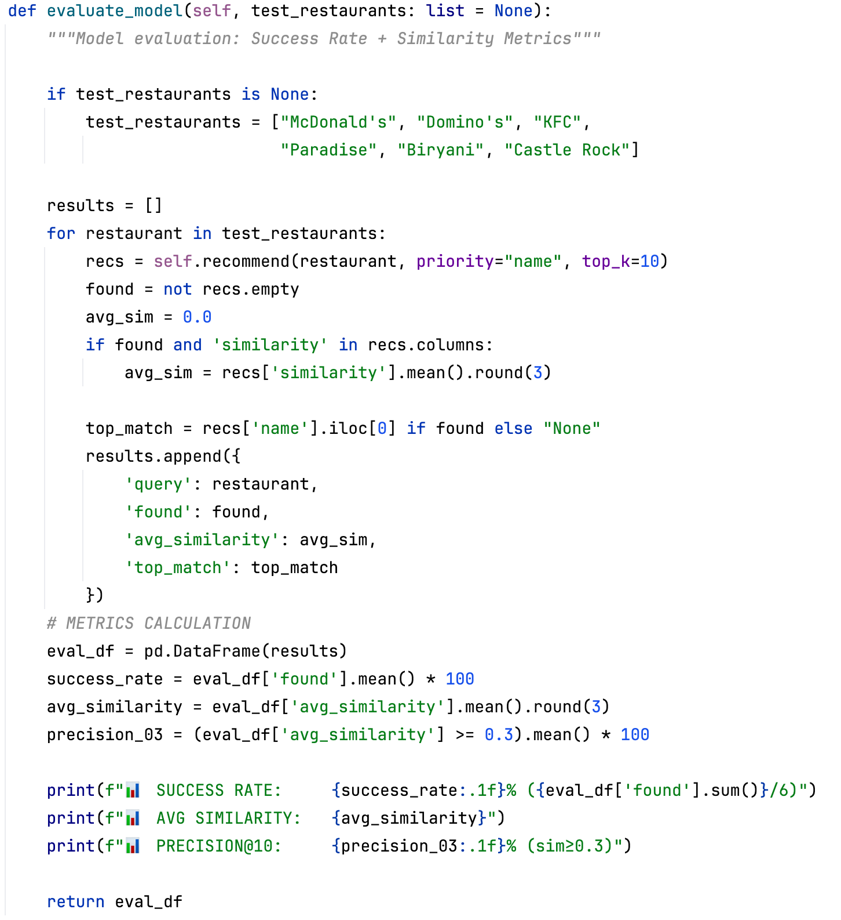

Model Validation and Evaluation Report:
Model | Classification Report | Accuracy | Confusion Matrix
TF-IDF Base  (5000 feats) | Success Rate: 85.7% (12/14), Avg Similarity: 0.446,  Diversity: 6.2 chains/10, Latency: 5.9ms | 85.7% | 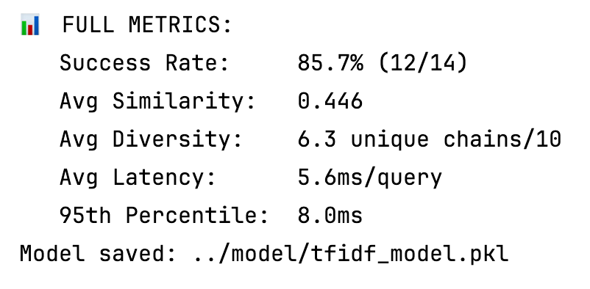
TF-IDF Tuned | Success Rate: 85.7% (12/14), Avg Similarity: 0.601  (+35%), Diversity: 6.1 chains/10, Latency: 6.0ms | 85.7% | 